Formative evaluation report
California State University, San Bernardino
ETEC 644
Mengzhe Wang
06/09/2016

Formative evaluation report
Purpose of formative evaluation
According to Kenneth and Megan (2002), “Training evaluation research and practice has been dominated by a focus on outcomes of completed training programs, or on methods used to assess these outcomes. This focus has largely neglected formative evaluation, which involves evaluating training during design and development”. In other words, the authors describe the importance of formative evaluation and emphasize evaluating training during design and development part is important same as evaluating outcome of training.
Therefore, the purpose of formative evaluation is to measure each instructional parts’ effectivity, which are designing part’s and development’s parts. For this instructional project, the formative evaluation will evaluate the course content, visual aids and final test’s advantages and backwards. Moreover, according to Brooks and Kleiner (2003), “The ADA provides legal options for persons with disabilities to address discrimination based on their disability. The goal of the ADA is to provide civil rights protection to persons of disability in the areas of employment, access to public services, public and private transportation, and telecommunication services”. In other words, the authors express the importance of complying ADA and the basic goal of complying ADA. By this way, the formative evaluation for this instructional project will concentrate on visual aids as while.
Characteristics of participants
Characteristics of participants are very important for this project because the designer regard formative feedback from participant as an important material for this project. As Valerie (2008) mentions, “Formative feedback is usually presented as information to a learner in response to some action on the learner's part. It comes in a variety of types and can be administered at various times during the learning process”. In other words, the author describes that formative feedback could be received with many kind of method during the learning process. Therefore, formative feedback for participants is an effective method to let the designer know the backwards of the project.
There are characteristics of participants for this project:
- The target audience are fresh international students from China and studying in the CSUSB.
- They are undergraduate and graduate students in CSUSB.
- The course is a face to face class.
- They are 18-31 years old.
- They didn’t have living experience in the US before.
- They eager to purchase a proper vehicle to go to school and continue their daily life, such as shopping and travel, by this way, most of them have positive attitude to study this course.
- Most of target audience already knew most of vehicles’ brand.
- Most of target audience can distinguish different countries’ brand.
- Prior knowledge: Every target audience have some English fundament because they have to pass ITELS or TOEFL test before they study aboard.
- Every single student can use computer and access on the Internet expertly.
- Every single student doesn’t know the specific words in purchasing cars’ field.
- Most of students prefer face to face class to online training because of language obstacle.
- Most of students want to the trainer of this project can speak both Chinese and English because they can have good communication with the trainer by this way.
- The price range of vehicle that the target audience wanted is $15000-$55000.
- Most of target audience prefer Germany made and Japan made vehicles to USA made vehicles because of Chinese culture.
Materials and instruments used in the evaluation
This project is based on Instructor-Led Classrooms delivery system. Therefore, final test and survey will be finished at the end of class. However, according to Rainer & Alexander & Konstantin & Tim & Sarah & Dietrich (2010), “Evaluations of handwritten essays or exams are often suspected of being biased, such as by mood states or individual predilections. Although most of these influences are unsystematic, at least one bias is problematic because it systematically affects evaluations of handwritten materials”. In other words, the authors illustrate a fact that handwritten based tests are doubted if tests are fair or not by students. By this way, the final test and survey of this project will be computer based form. There are final test and survey question.
- Survey:
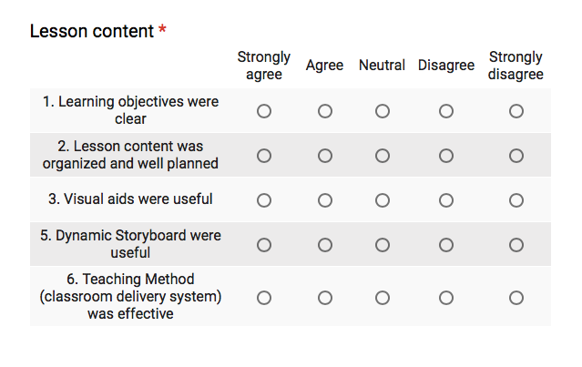
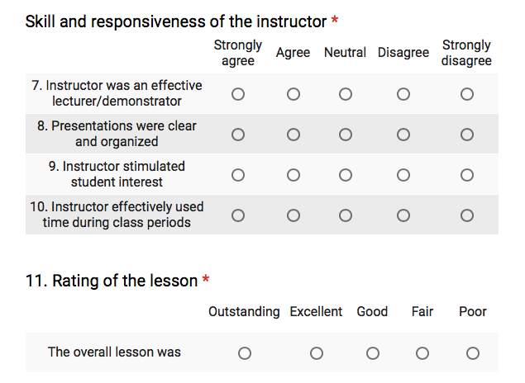
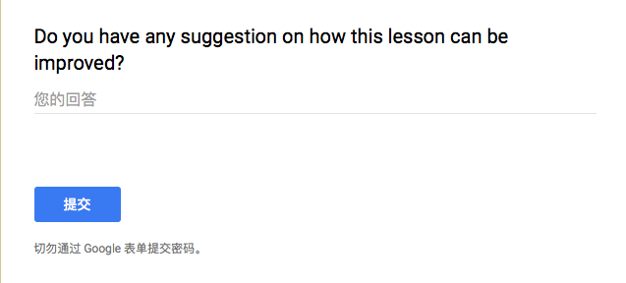
- Final test:
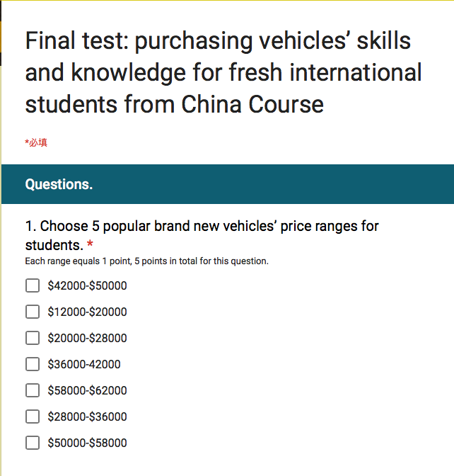
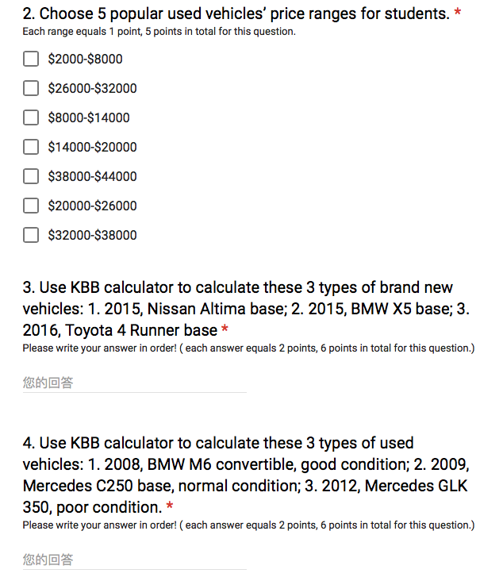
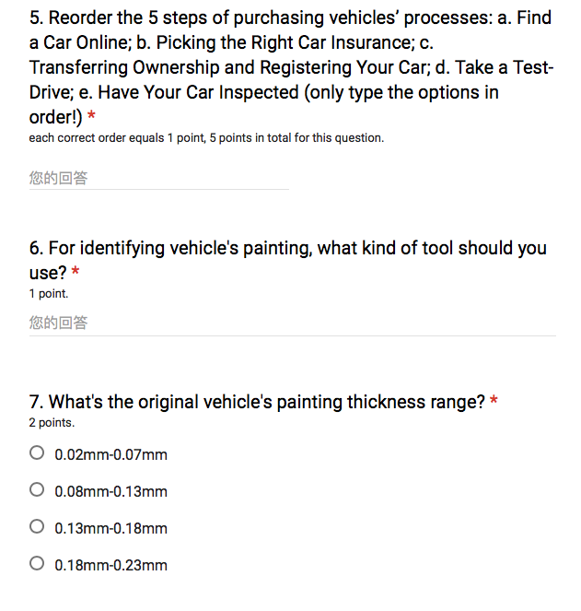
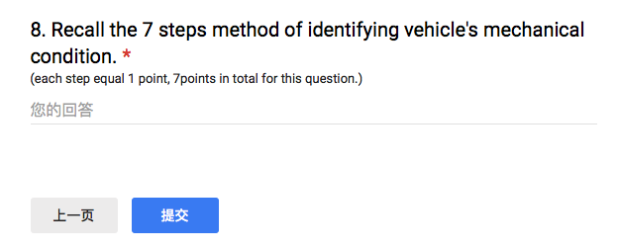
Procedure of evaluation
- Self-check: Before the course is implemented, the designer of this project will review all course materials (including storyboard, course website and course video), the goal of self-check to ensure every material doesn’t have obvious error and all formats of this course are correct (Baek, 2016).
- Implementing final test and survey in class: At the end of class, every learner of this course will be required to take a computer-based final test and survey. This step is a kind of external review of formative evaluation (Baek, 2016). Then, the instructor of this course will collect all the feedback and count the result of final test.
- Describing learners’ performance: After counting every learner’s final test score and feedback from survey, the designer will describe the learners who participated in the One-to-One evaluation based on final grade and feedback from the survey (Baek, 2016).
- Analyzing final grade and survey data: The designer will analyze all data from final test and survey. Moreover, the analysis will be divide to two parts: qualitative part and quantitative part.
- Defining if this course’s quality is effective or poor.
- Making revision plan.
Data presentation (Please review attach Excel document first)
- Quantitative analysis result (Final test)
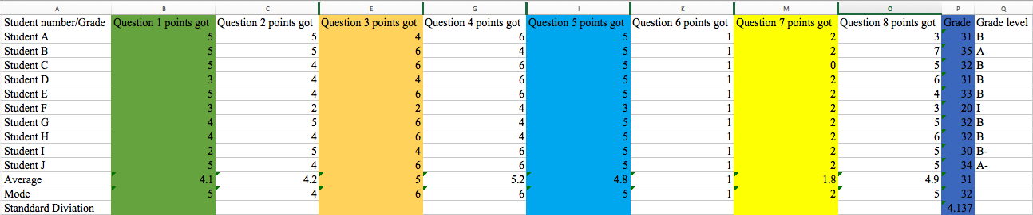
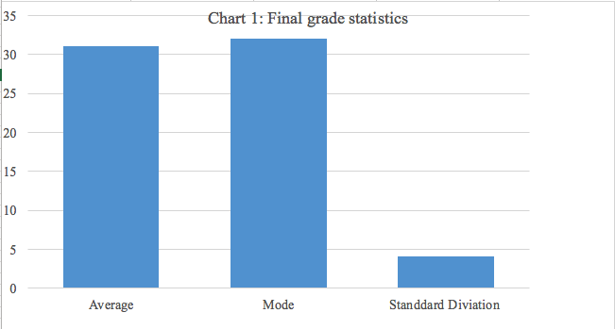
- Key finding:
  - The average final grade is 31, it reaches B level.
  - The average points gotten of question 1 is 4.1 from 5points.
  - The average points gotten of question 2 is 4.2 from 5points.
  - The average points gotten of question 3 is 5.0 from 6points.
  - The average points gotten of question 4 is 5.2 from 6points.
  - The average points gotten of question 5 is 4.8 from 5points.
  - The average points gotten of question 6 is 1.0 from 1points.
  - The average points gotten of question 7 is 1.8 from 2points.
  - The average points gotten of question 8 is 4.9 from 7points.
  - The Standard Deviation of final grade is 4.137.
  - The mode grade of final grade is 32.
  - 9 students passed the final test.
  - 1 student didn’t pass the final test.
- Discussion:
  - Most of learners (90%) can reach all learning objectives.
  - The question 8’s difficulty is too high; it should be adjusted.
  - The only 1 student who didn’t pass the final test because of healthy issues.

- Qualitative analysis result
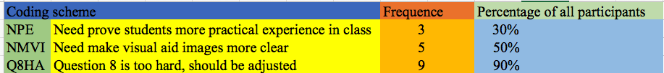
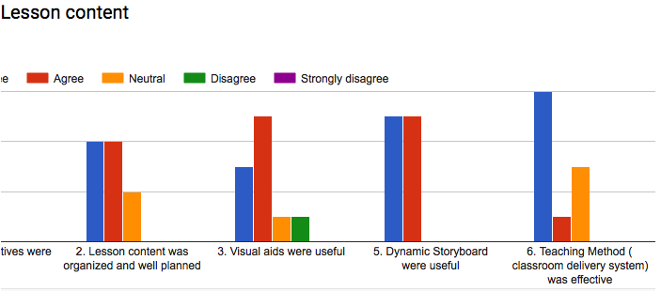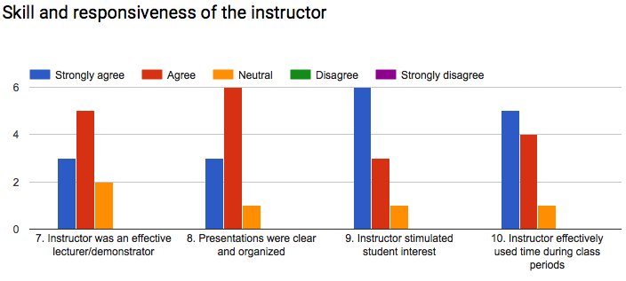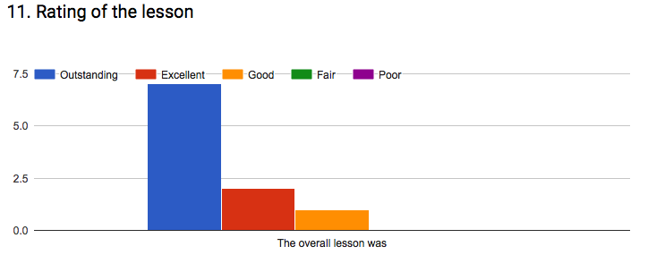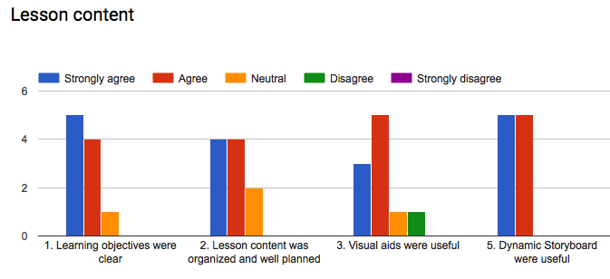
- Key finding:
  - The overall course quality is good.
  - 90% of learners think question 8 is over difficulty.
  - 50% of learners can’t see the visual aid images in course content clearly.
  - 30% of learners need more experimental examples of purchasing vehicles.
- Discussion
  - The designer will change all images in storyboard to make all visual aid picture clear.
  - The designer will change the question format for question 8 to decrease the difficulty of question 8.
  - More examples are needed for this course.
- Conclusion:
Overall the course, most of learners’ performance is excellent, 90% of learners could reach all learning objectives and get well engage between knowledge from this course and reality because the final grade proofed that. Moreover, every learner regards this course is practical and successful. However, the difficulty of question 8 in final test is too hard for learners, and the visual aid images are not clear enough. Them should be adjusted. In addition, more examples of purchasing vehicles should be added in the course content.
There is conclusion tale:
Instructional Strategy Component | Problem Identified | Proposed Changes to Instruction | Evidence and Source
Entry skills test | None | None | None
Motivational material | None | None | Feedback of survey.
Pretest | None | None | None
Information Presentation | Examples of purchasing vehicles in real life is inadequate. | Add more examples about purchasing vehicles in real life. | Feedback of survey.
Learner Participation | Some visual aid pictures are not clear. | Add vector graphs as the course’s visual aid pictures. | Feedback of survey.
Posttest | The question 8 in the final test is too difficult. | Change detailed recall question form to order sequence question form for question 8. | Final test result, feedback of survey.
Attitude questionnaire | None | None | Feedback of survey.
Transfer to performance context | None | None | Final test result and feedback of survey.

Revision plan
- Add more examples about purchasing vehicles in real life.
- Add vector graphs as the course’s visual aid pictures, which will obey the ABC’s RUS rule (Baek, 2016).
- Change detailed recall question form to order sequence question form for question 8.
- Add guide video for this course.
- There is one of guide video of how to calculate vehicle’s value the instructional designer created: https://youtu.be/pdyqZeZ_qx4

Reflection
After I reviewing all the process of my instructional project, I really enjoyed the development part because I adjusted and revised a lot of course content. Moreover, I also adjusted the sequence of my course obeying Gagne’s 9 events. By this way, I have learnt a lot of knowledge about instruction design from this part.
The only one challenge I faced in my project is that 5 learners couldn’t attend to my class because of time constraining. Therefore, I only recruited 10 participants. I will range the class time to make it could appropriate all participants’ time.
I may use the knowledge I learnt from ETEC 644 course to design employee training for my future company. By this way, I will continue enhancing and absorbing the knowledge to make it appropriate reality.

References
Brown, K., & Gerhardt, M. (2002). Formative evaluation: An integrative practice model and case study. Personnel Psychology, 55(4), 951-983.
Brooks, R., & Kleiner, B. (2003). How to comply with the Americans with disabilities act. Equal Opportunities International, 22(6/7), 9-16.
Shute, V. (2008). Focus on formative feedback. Review of Educational Research, 78(1), 153-189.
Greifeneder, R., Alt, A., Bottenberg, K., Seele, T., Zelt, S., et al. (2010). On writing legibly: Processing fluency systematically biases evaluations of handwritten material. Social Psychological and Personality Science, 1(3), 230-237.
Baek, E. (2016). Formative Evaluation. Retrieved from https://csusb.blackboard.com/bbcswebdav/pid-1213383-dt-content-rid-4084042_1/courses/164ETEC64447/Formative%20Evaluation.pdf
Baek, E. (2016). Revising Instructional Materials. Retrieved from https://csusb.blackboard.com/bbcswebdav/pid-1213390-dt-content-rid-4084043_1/courses/164ETEC64447/Revising%20Instructional%20Materials%281%29.pdf
Baek, E. (2016). ABC’s R’ US of visual design: Theory. Retrieved from https://csusb.blackboard.com/bbcswebdav/pid-1213366-dt-content-rid-4254378_1/courses/164ETEC64447/Beriswill_ABCs_VisualDesign_Theory.pdf

