Research study report: The relationship between before class quizzes and students’ final grade in high school’s Trigonometric Function class.
Mengzhe Wang
California State University, San Bernardino
College of Education: ETEC 643
Abstract
Trigonometric Function is an important part in mathematic subject in Chinese high schools. However, Trigonometric Function is a specific difficult point in Chinese high school’s mathematic subject. Moreover, there were many posers presented in Chinese College Entrance Examination during recently years. This research concentrated on the relationship between quizzes and final grade in high school’s Trigonometric Function classes. The proposal is finding the way to improve students’ Trigonometric Function final grade and the measurable criteria is based on students’ final grade in Yaohua high school,Tianjin. The measureable method is comparative t-Test and teacher’s experiences. The expert is giving students proper quizzes to improve students’ final grade in high school’s Trigonometric Function effectively.

Keywords: Trigonometric Function, quizzes, final grade, t-Test.

Introduction
Asian education is always an important thing for high school students’ parents because the competition is very intense in the society, and many parents have a faith in that the higher education their children can get the better future that their children could have. Therefore, the first thing that parents care about is how high the scores that their children get from school. Teachers then carry the same pressure as the children do because parents have so many high hopes and teachers have big weights of responsibility.
This research study is going to find out whether quizzes can improve students’ scores and understanding. The background of this project is Yao Hua High School in Tianjin province, China. Moreover, this research will concentrate on Chinese Exam-Oriented Education System because Chinese population sacle is huge, but education resources’s scale is small. Therefore, Improving students’ grade is a partical research because of Chinses unique educational environment.
In addition, this research will major in Trigonometric Function class in high school because this subject is the most difficult part in Chinese College Entrance Examination. If students could get some progress in this subject, their grade in Chinese College Entrance Examination will reach a higher level.
Literature Review
The literature is related to implement of quizzes, 19 mathematics classes in 5 high schools in 3 states were studied, and the result is different quizzes frequency could influence students’ final grades efficiently. The highest frequency quizzes mathematic could make students’ final grades be the highest, and the contray situation in non-quizzes mathematic class. In addition, the teachers' knowledge and beliefs, as well as the content and textbook of the course, also could influence the characteristics of test items and other assessment instruments. (Senk. & Beckmann & Thompson, 1997)
According to the statistic, study aimed at investigating the effect of weekly quizzes on Iranian high school students' performance on final achievement tests. This effect, which is technically referred to as wash back, is defined as the effect of testing on learning and teaching. Most scholars have attempted to provide guidelines in order to achieve positive wash back. While some suggest frequent quizzes as a means of positive wash back, others oppose the idea. (Gholami, 2013)
Reviewing quizzes can give students feedbacks and assist in preparation with in-class-test. The study use two semesters to study the affection of the time line while a quiz was applied. For example, one semester was applied with quizzes taken before completion of chapters while the other applied quizzes after completion of chapters.（Advances in Physiology Education. 2015）
A statistics-study & teaching, there were 2 group involved in this study. One group engaged with pre-lecture quizzes while the other didn’t. Students who were in the pre-quizzes felt that pre-quizzes did help them keep up the courses and felt better in the course. (Education 2015)
Quizzes can give students feedbacks and assist in preparation with in-class-test. The study use two semesters to study the affection of the time line while a quiz was applied. For example, one semester was applied with quizzes taken before completion of chapters while the other applied quizzes after completion of chapters. The outcome numbers show that this class with quizzes taken before chapters has better scores in average. (Advances in Physiology Education, 2015)
The policy argument that Chinese Exan-riented Education shows that Chinese education only can make students get academic success. Therefore, high school should focus on improving student psychological health, but Chinese education environment doesn’t allow to do that right now. By this way, improving students grade is the essential thing to do in high school. (Kirkpatrick & Zang, 2011).
According to Gonzalez-Tablas & Fuentes & Hernandez-Ardieta & Ramos (2013), there exists the need of engaging students in performing drill and practice activities with the goal of reinforcing routine mathematical skills. The usual optionality of these tasks entails the risk of students not fulfilling them in an effective way. Although competitive approaches are not a trend in current educational practices, there are several arguments that support their use in higher education for addressing this problem, provided that the negative effects of pure interpersonal competitions are mitigates. These resources can significantly proof that quizzes have positive effective to students, but it depends the number of quizzes and the time. By this way, this research also will find the best way to run quiz during the class.
Research question & null hypothesis
This research study’s research question is:
Does quiz improve students’ grade in Chinese high school Trigonometric Function class? If it does, what’s the proper way to run quiz before class?
This research study’s null hypothesis is:
Before class quiz will not improve students’ grade effectively and will not make students’ grade level be stable.
Design & Methodology
Research design
The research question here is, Does quiz improve students’ grade in Chinese high school Trigonometric Function class? If it does, what’s the proper way to run quiz before class? Therefore, this research study will use Mixed-Method to process the information about this research. This study’s purpose is identifying whether quizzes enhance especially students’ scores or not because most of people have quizzes during their student lives. This research will get p-Value, central tendency, standard deviation, frequency and coding scheme in the end of research.
In this research, the dependent variable is students’ final grades. On the other hand, teacher’s perspective to Trigonometric Function section and whether giving quizzes before class or not are independent variables. By this way, this study will compare same level students (students have same level intelligence and the two class with a same teacher.) to limit and measure dependent variables. Moreover, the central criterion is students’ final grade.
Participants
This research is concentrated on high school students, and the two classes have 40 students in total in Yaohua high school, Tianjin, China. These 40 students come from two classes with one teacher. Moreover, these two classes each contain 20 students and these two classes’ students have same level intelligence because all students already passed the enter school test before.
Data collection
This research will collect mixed data because the researcher decided to use mixed-method research. By this way, the researcher will combine quantitative data collection method and qualitative collection method.
Students’ final grade from the teacher and teacher’s perspective from teacher interview. Moreover, the student’s grade is from a Standards-based test, and the teacher invents this test. The test will only have fixed answers, by this way, the final grade will be both validity and reliable.
In terms of data collection methods, the teacher interview will be given to the teacher after the final test. The search could collect qualitative data by doing teacher interview. The reason why the research chose to do teacher interview is teacher’s perspective about the relation between quizzes and grade is important because the teacher come up with the final test and quizzes questions. By this way, the teacher’s perspective is validity and reliable. In addition, The interview is an e-mail contact for our qualitative question because it is relatively fast and easy to manage to questions. Plus, it also saves our time and solves the inconvenience from the distance. The researcher arrange a proper time with the teacher, who is teaching in Yao Hua high school for 20 years. She has been in the field for a long time, and has a lot of experience. Therefore, she is a right person to interview.
Instrument development
Teacher interview question:
Question 1, Do you agree that students who take before class quizzes can get higher grade than the other students who don’t take quizzes in high school Trigonometric Function class only because of quizzes?
Question 2, What’s the benefit that students taking before classes quizzes?
Question 3, According your own experience, how long the quiz should take and how many questions the quiz should contain is the most effective?
Question 4, Why did you give only one of two classes before classes quizzes?
Question 5, Do you have any other information you would like to tell me?
Teacher interview proposal: Our group wants to find a good way to improve student’s Trigonometric Function grades. We want to collect final grades of students’ Trigonometric Function class data for our quantitative data, and we also plan to do interview with a mathematic teacher by Skype for our qualitative data. Then we want to analyze these data and find the best way to improve students’ grades.
The teacher interview is both validity and reliable because the teacher’s income doesn’t have any relationship with students’ grade and the two classes’ students has the best intelligence in the high school.

Analysis
This research will use coding scheme to analyze qualitative data. Then, the research will insert quantitative data to Microsoft Excel to analyze t-Test and quantitative data. By this way, the result will be accurate and will avoid outside factors. Moreover, the teacher’s interview answer will be summrized and insert coding scheme in Excel.
Result (Finding)
Quantitative research result
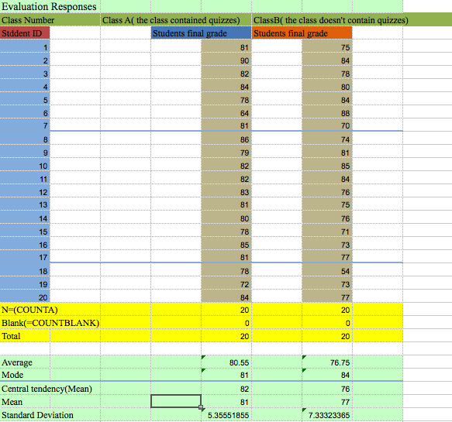
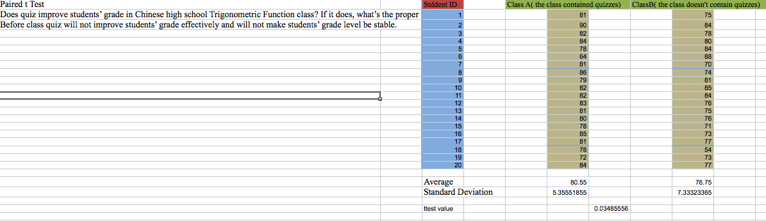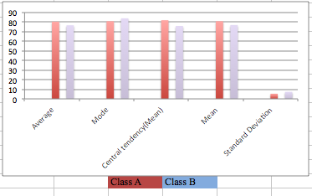
Above pictures came from the Excel, and the researcher did that Excel block to analyze the quantitative data.
There is key finding:
- Quizzes given class’s average grade is 81.
- Quizzes given class’s mode grade is 81.
- Quizzes given class’s mean central tendency grade is 82.
- Quizzes given class’s mean grade is 81.
- Quizzes given class’s grade’s standard deviation is 5.3.
- Non-quizzes class’s average grade is 77.
- Non-quizzes class’s mode grade is 64.
- Non-quizzes class’s mean central tendency grade is 76.
- Non-quizzes class’s mean grade is 77.
- Non-quizzes class’s grade’s standard deviation is 7.3.
- The two classes’ t-Test’s p-Value is 0.034.
Qualitative result
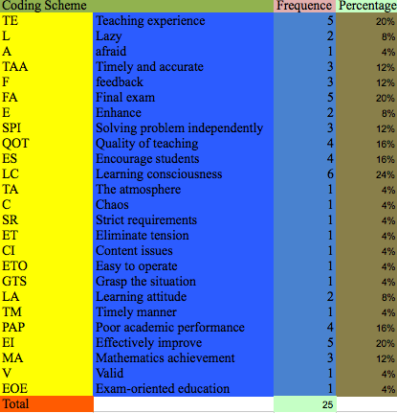

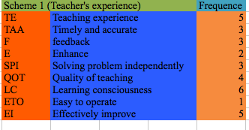
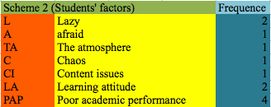
Above are teacher interview coding scheme that the researcher did by Excel. Moreover, the original teacher interview document and coding document will attach with the final report.
There is key finding:
For teacher’s perspective:
- Feedback is easy to get by quizzes.
- Quizzes could make timely and accurate feedback from students.
- Quizzes could enhance students’ independent solving problem ability.
- Teaching experience, effectively improve and final exam are high frequent words.
For students’ factors:
- Highest frequent word is Learning consciousness.
- Lazy is one of the factors that student survey could be invalidity and unreliable.
- The atmosphere is one of the factor that student might be in final exam.
- Learning attitude is one of important factors that the quiz should be given.
- Poor academic performance might be caused without quizzes class.
- Chaos is one of the factor that student might be in final exam.
Discussion
Qualitative research implications:
This research study includes one teacher interview. The teacher interview shows that the limitation of student survey, the proper way to run before class quiz and the relationship between before class quiz and final grade by teacher’s experience and perspective. By this way, the teacher interview’s coding could be divided to 2 categories.
The first category could be named as Teacher experience. Code TE (Teaching experience) and TAA (Timely and accurate) , F (Feedback) and E (Enhance) and EI (Effectively improve) are related to the function of quiz, it refers that quiz could get students’ feedback of Trigonometric Function subject before the final examination. There is a well-known fact that finding the problem before the result coming out is important to enhance and improve the result. By this way, before class quiz could get students’ learning feedback timely and accurately, and it also could improve students’ final grade effectively. Code SPI (Solving problem independently), QOT (Quality of teaching), LC (Learning consciousness) and ETO (Easy to operate) are related to the proper way to run before class quiz and the benefit of quiz, it refers that the proper quiz duration is 5 minutes, the number of questions for each quiz should be 1-2, after quiz, teacher should take 2 minutes to comment question. By this way, quiz could improve students’ the ability that solving problem independently and quiz also could eliminate students’ learning consciousness. Moreover, quiz is easy to operate by teacher, by this way, teacher could easy to reach quality of teaching, that means quiz is an efficient way to improve the quality of teaching, students could absorb more knowledge in quiz given class.
The second category could be named as students’ factors. Code L (Lazy), A (Afraid), TA (The atmosphere), and C (Chaos) are related to the limitation of students survey, it refers that when the researcher do students survey about quiz, students might not reflect the true perspective because students might be lazy, afraid of quiz and might be chaos when they take quiz or exam. Code CI (Content issues), LA (learning attitude) and PAP (Poor academic performance) are related to the improvement of quiz, it refers that before class quiz could reflect the content issues in time, and quiz also could promote students to warm up what they have learnt. Moreover, quiz also could help students correct their learning attitude effectively.
Quantitative research implications:
The p-Value is 0.034, this value is less than 0.05. Therefore, this value rejects the null hypothesis. By this way, before class quiz could improve students’ final grade in Chinese high school Trigonometric Function subject effectively.
The average final grade from the Excel file shows that class A (Before class quiz class) has 4 points greater than the class B (Non-quiz class). The class A also has 4 points greater than the class B in mean grade, 6 points greater than the class B in mean central tendency grade. These values illustrate that Before class quiz given class has better learning performance than Non-quiz class. Moreover, the class A has 3 points less than the class B in mean grade, and the class A has 2 points less than the class B in standard deviation value. These values show that Before class quiz given class has more balanced grade than Non-quiz class.
Limitations in the research study:
The first limitation is that the sample group and the number of interview group are too small to make the research be more general.
The second limitation is that this research contains a lack of students survey because students’ perspective that if quiz is given before class or not might be unfair because of students already endured too much pressure, they might be lazy or tired to take extra quiz before class.
Conclusion
In conclusion, the research explored that quiz could improve students’ final grade effectively in Chinese high school Trigonometric Function class. The proper quiz that would be given before class should contain 1-2 questions, and the duration should be 5 minutes. Teacher should comment the quiz for 2 minutes after the quiz finished. Moreover, quiz is easy to operate by teacher. Therefore, the researcher suggests that high school Trigonometric Function teacher should run quiz before. By this way, the students’ learning attitude will be correct, their grade will raise, and the students will not have any negative perspective during the final exam because quiz could help students warm up knowledge and get over their negative mood.
In addition, this research result is accord with the literature review that described the proper way to run quiz. This research is accord with Chinese education environment. Therefore, this research result is validity and reliable.
Researcher reflection
During this research, I found that I should enhance the data collection part to make my research be more general. However, the people item resource I had was too few. Therefore, I realized that I should change my people item from few to rare. By this way, I could run huge scale research in the future.
On the other hand, I really enjoy the research process. Actually, it’s my first time to run a personal research, I realized that I have many backwards in the research, but I already tried my best to solve these problems. For example, I used to plan to do students survey, but I found that I couldn’t do a fair and objective survey, and then I changed my planning.
At last, I would say that doing a research is useful for me because I could use that in my future job.

References
Education. Spring2015, Vol. 135 Issue 3, p346-350. 5p.
Advances in Physiology Education. 6/1/2015, Vol. 39 Issue 2, p63-66. 4p.
International Journal of Modern Education and Computer Science, volume 5 issue 1 (1 January, 2013), pages 36-41.
Kirkpatrick, R. & Zang, Y. (2011). The negative influences of exam-oriented education on chinese high school students: Backwash from classroom to child. Language Testing in Asia, 1(3), 1-10.
Senk, S. Beckmann, C. & Thompson, D. (1997). Assessment and grading in high school mathematics classrooms. Journal for Research in Mathematics Education, 28(2), 187-215.
Gholami, V. & Moghaddam, M. (2013). The effect of weekly quizzes on students' final achievement score. International Journal of Modern Education and Computer Science, 5(1), 36-41.
Gonzalez-Tablas, A. , de Fuentes, J. , Hernandez-Ardieta, J. , & Ramos, B. (2013). Leveraging quiz-based multiple-prize web tournaments for reinforcing routine mathematical skills. Educational Technology & Society, 16(3), 28-43.

