Design Document
Mai Yang Xiong, Jun Cai, Mengzhe Wang, Jon Leonardo Rodriguez
1. Project Title: Volume of Solids with known Cross Section
2. Learning objective:
At the end of the lesson, students will be able to write a definite integral for the volume of a solid, with known cross section, and integrate it to find the volume.
3. Target audience
Our target audience is high school students enrolled in AP Calculus AB. They are 17-18 years old, juniors (11th grade) or seniors (12th grade). Since they have taken 1 semester of AP Calculus AB with Ms. X as a face-to-face class, differentiation basic integration (for both indefinite and definite integrals), and finding areas between curves are taught already. In addition, majority of the students have access to Internet at home and only 1 student do not have access to Internet at home.
4. Content outline
- Definition of a Cross Section: A slice of a solid.
- Definition of Volume of Solids as a definite integral: $V=\int_{a}^{b}{A\left(x\right)dx}$
- Notations in the definition of volume of a solid and how it relates to the solid (for example the integral symbol, the upper and lower limits, A(x), and dx).
5. Delivery system
The project uses classroom delivery method for a 1-day lesson on Volume of Solids with known cross section. Classroom delivery method is most appropriate because the course is a face-to-face class in a public school setting. Ms. X, who is the mathematics instructor and content expert, will teach it. The instructor will utilize curriculum materials, such as textbook, and any technologies (laptop, chromebook, LCD projector, document camera, and graphing calculator) provided to her from her school to delivery the lesson. Included with the classroom delivery method, visual aids and interactive materials, available from online dynamic mathematics software (Geogebra) will be utilized to assist students during the lesson.
According to Piskurich (2015) one of the constraints to using the classroom delivery method is that it relies mostly on the instructor’s knowledge. The instructor is the content expert in developing content materials and will deliver the lesson. As a result, the audience (the students) can be bored depending upon the instructor’s interaction and skills. In addition, the lesson may teach to the “mid-range performance level” (p. 126) and may not be able to meet the needs of every single student. Another constraint to classroom delivery system is inconsistency of the lesson if the instructor has to deliver it multiple times (Piskurich, 2015). However, since Ms. X has only 1 AP Calculus AB class, she will only be delivering the lesson once.
6. Flowchart
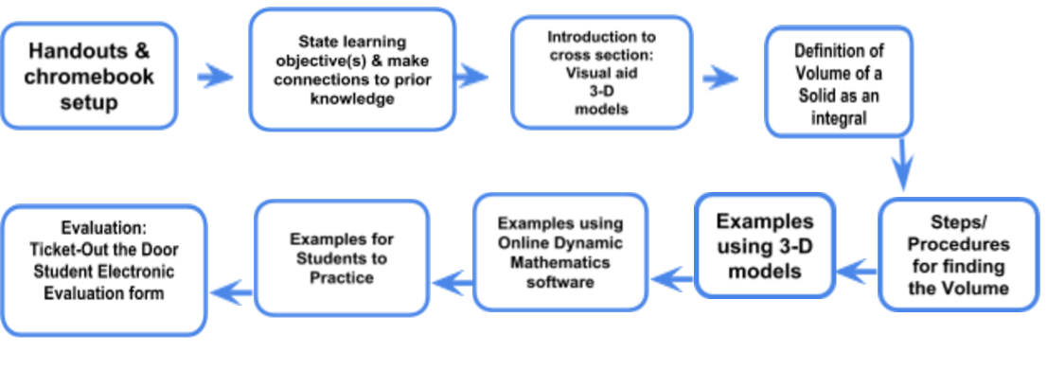
- Handouts & chromebook setup: The handouts are given to students to take notes on. They need to include examples for students to take down notes and helpful hints to assist them. Include any visual aid on the handout. Also include any calculator directions to assist students in using their graphing calculator.
- State the learning objective(s) & make connections to prior knowledge: Stating the learning objective provides a focus for the instructor and the student. In addition, tie what students have learned in the previous lesson to this lesson. It helps guide students in understanding how this lesson relates to the unit of study.
- Introduction to Cross Section: Visual aids and 3-D models, a class set, are used to introduce students to the concept of a cross section and its relation to the volume of a solid.
- Definition of Volume of a Solid as an Integral: Explain the notations in the definition of volume of a solid are and how they are related to the solid (for example the integral symbol, the upper and lower limits, A(x), and dx).
- Steps/Procedures for finding the Volume: Give steps/procedure for finding the volume using the cross section.
- Examples using 3-D models: Model with examples on how to use the step to find the volume of solids using the 3-D models. Students will take down notes and a variety of cross section such as squares, isosceles right triangles, triangles (in general), and rectangles will be used.
- Examples using Online Dynamic Mathematics Software: Model with examples using online dynamic mathematics software (Geogebra) interactive materials to assist student in visualizing the solids (especially if its base is generated by complex functions) and determining important information to use in their formula.
- Examples for students to practice: Give examples for students to practice and process the information taught in the lesson.
- Evaluation:
- The Ticket-Out the Door assessment is an assessment given at the end of the lesson to check for student understanding of the lesson. It consists of 1 problem (very basic and not too complex due to time constraint) that requires the students to find a formula for the area of the cross section, find the limits of integration, and integrate the area to find the volume.
- The Student Electronic Evaluation, created using Google form, will be given upon completion of the lesson. Student will evaluate the lesson content (learning objective, content, handout, visual aids, online dynamic mathematics software, and the delivery of the lesson). Students will also evaluate the instructor.

